Project Design Phase
Solution Architecture
Date | 06 October 2026
Team ID | SWTID-2026-9105
Project Name | Implement Client Script & UI Policy (Incident)
Maximum Marks | 4 Marks
Solution Architecture:
The solution architecture for this project bridges the Incident management problem with native ServiceNow configuration. It defines how the Incident form, UI Policies, UI Policy Actions, Client Scripts, validation logic, and Incident table work together to provide controlled and consistent Incident handling.
Architecture Goals
● Find the appropriate ServiceNow technology solution for the Incident data-quality problem.
● Describe the structure and behaviour of the configured Incident solution to project stakeholders.
● Define the configuration components and implementation phases required for the solution.
● Provide clear specifications for configuring, testing, and maintaining the solution.
Project Solution Architecture Diagram
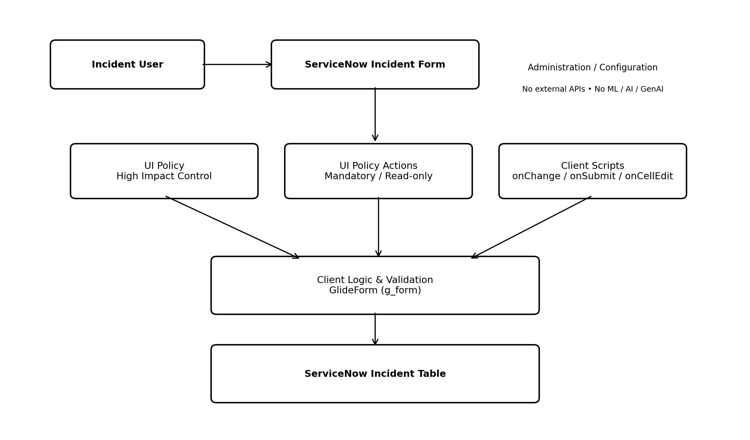
Architecture Components
Layer / Component | Implementation | Purpose
User Layer | Incident User | Creates and updates Incident records.
Form Layer | ServiceNow Incident Form | Provides the user interaction surface.
Configuration Layer | UI Policy + UI Policy Actions | Controls conditional mandatory and read-only behaviour.
Client Logic | onChange / onSubmit / onCellEdit | Automates updates, validates saves, and controls list editing.
Validation Layer | GlideForm (g_form) | Reads and updates fields and displays validation feedback.
Data Layer | ServiceNow Incident Table | Stores Incident records.
External Services | Not required | No external API or ML service is part of this project.
Implementation Flow
Incident User → Incident Form → UI Policy / UI Policy Actions and Client Scripts → GlideForm-based client logic and validation → Incident Table.
When Impact is set to High, the configured UI Policy controls the relevant fields and the onChange script sets Urgency to High. During submission, the onSubmit script validates the required assignment condition. From the Incident list, the onCellEdit script prevents direct State changes. Reverse-if-false restores normal conditional behaviour when the High Impact condition is removed.
Technology Applicability
● ServiceNow: Supported and central to the project.
● JavaScript / GlideForm: Used for Client Scripts and client-side validation.
● Power BI: Not required.
● Salesforce: Not required.
● Tableau: Not required.
● AI / Machine Learning / Generative AI: Not applicable.
● External APIs: Not required.
Reference
Solution Architecture template supplied as part of the project documentation, adapted for the ServiceNow Incident implementation.
Solution Architecture | Implement Client Script & UI Policy (Incident)

